Supply Chain Management (SCM) — NPTEL
Week 8 · Session 3: Demand Allocation Model & Capacitated Plant Location Problem
1. Recap — Week 8 So Far
Session | Topic | Method / Tool
W8 S1 | Facility Selection | Break-Even Analysis
W8 S2 | Facility Location | Centre of Gravity + Excel Solver (GRG Nonlinear)
W8 S3 | Demand Allocation + Capacitated Plant Location | LP formulation + Excel Solver (Simplex LP / Binary)

★ This session adds 2 new models: Demand Allocation (which plant serves which market?) and Capacitated Plant Location (which plants to open at all?).
2. Case Study — Two Telecom Equipment Manufacturers
The Companies
 | Maxxio | Wavie Communications | MaxV (Merged)
Plants | Delhi, Gurugram, Kolkata | Chennai, Mumbai | All 5 (then optimized to 3)
Markets | New Delhi, Kolkata, Lucknow | Chennai, Hyderabad, Mumbai | All 6
Region | North + East India | South + West India | Pan-India
Capacity/month | 76,000 units | 48,000 units | 1,24,000 units
Demand/month | 34,000 units | 30,000 units | 64,000 units

Given Data (Parameters)
- Variable cost (production + transportation) per 1,000 units — from each plant to each market
- Monthly capacity of each plant (supply limit)
- Monthly demand at each market
- Monthly fixed cost for each plant
 | Demand City Production and transportation cost per thousand units (thousand INR)
Supply City | New Delhi | Kolkata | Lucknow | Chennai | Hyderabad | Mumbai | Monthly Capacity (Thousand Units) | Monthly Fixed Cost (Thousand Rupees)
Delhi | 1,500 | 500 | 670 | 1,600 | 1,200 | 2,900 | 20 | 8,000
Chennai | 1,540 | 2,390 | 960 | 90 | 500 | 1,300 | 23 | 4,000
Mumbai | 2,000 | 2,500 | 1,300 | 450 | 950 | 900 | 25 | 5,600
Gurugram | 400 | 1,400 | 600 | 1,200 | 560 | 2,400 | 24 | 4,200
Kolkata | 1,080 | 1,700 | 650 | 540 | 321 | 1,800 | 32 | 2,400
Monthly Demand (Thousand Units) | 12 | 7 | 15 | 8 | 12 | 10 | - | -

★ Both companies: capacity > demand → enough production to fulfill all markets. Decision is HOW to allocate, not whether.
3. Demand Allocation Model
- Question: how much quantity should be shipped from which plant to which market to minimize total cost?
- Solved separately for each company (Maxxio and VV) in Phase 1
Notation
- C_{ij} = unit cost of production + transportation from plant i to market j
- X_{ij} = quantity to be shipped from plant i to market j ← decision variable
- S_{i} = supply capacity of plant i
- D_{j} = demand at market j

LP Formulation — Demand Allocation

Demand Allocation Problem
Minimize Z | Σi Σj (C_{ij} × X_{ij}) [total production + transportation cost]
Supply constraint | Σj X_{ij} ≤ S_{i} for all i [supply from plant i ≤ its capacity]
Demand constraint | Σi X_{ij} = D_{j} for all j [demand at market j must be fully met]
Non-negativity | X_{ij} ≥ 0 for all i, j
Allocating Demand to manufacturing Facilities
- Goal is to allocate the demand from different markets to various plants to minimize the total cost of facilities, transportation, and inventory.
- For both Maxue and Wavie, the demand allocation problem can be solved using the Solver tool in Excel.
- The optimal demand allocation is presented in the last slide Table.
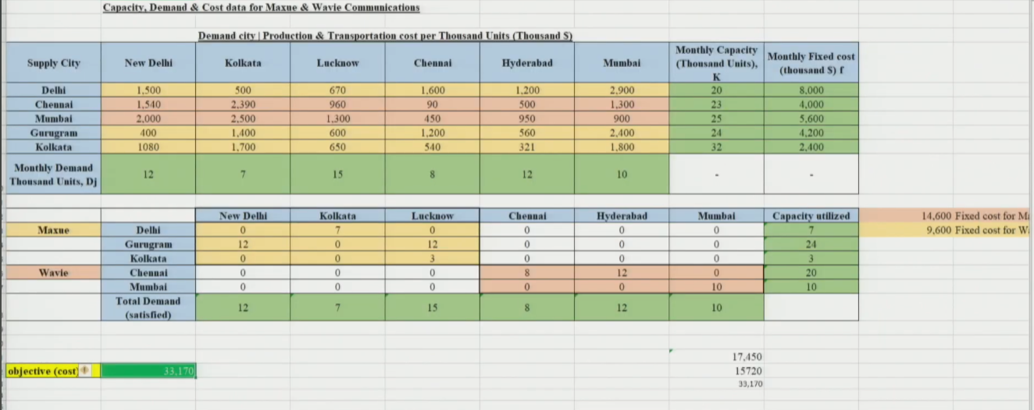
 |  | New Delhi | Kolkata | Lucknow | Chennai | Hyderabad | Mumbai | Capacity utilized
Maxue | Delhi | 0 | 7 | 0 | 0 | 0 | 0 | 7
 | Gurugram | 12 | 0 | 12 | 0 | 0 | 0 | 24
 | Kolkata | 0 | 0 | 3 | 0 | 0 | 0 | 3
Wavie | Chennai | 0 | 0 | 0 | 8 | 12 | 0 | 20
 | Mumbai | 0 | 0 | 0 | 0 | 0 | 10 | 10
 | Total Demand (satisfied) | 12 | 7 | 15 | 8 | 12 | 10

Key Insight from Solution (Maxxio)
- Kolkata facility is barely utilized despite fixed cost being incurred (because of high costs of production)
- Reason: high production + shipping cost from Kolkata makes it uneconomical
- But fixed cost is still paid → inefficiency
- This signals a need for a smarter model that also decides which plants to open
- Observe that it is optimal for Maxue not to produce everything in the Kolkata facility because of high costs of production and shipping even though the facility is operational and the fixed cost is incurred.
- Maxue incurs a monthly variable cost of ₹17,450,000 and a monthly fixed cost of ₹14,600,000, for a total monthly cost of ₹32,050,000.
- Wavie incurs a monthly variable cost of ₹15,720,000 and a monthly fixed cost of ₹9,600,000, for a total monthly cost of ₹25,320,000.

4. Merger Scenario — Maxvie (Maxxio + Wavie)
- Management merges Maxxio + Wavie into a new company: Maxvie
- Now has 5 plants and needs to serve 6 markets across India
- New question: which plants to keep open? Can any be shut to reduce cost?
- Management executives at both Maxue and Wavie have decided to merge the two companies into a single entity to be Maxvie.
- Management believes that significant benefits will result if the two networks are merged appropriately, Maxvie will have five factories from which to serve six markets.
- Management is debating whether all five factories are needed. It has assigned a supply chain team to study the network for the combined company and identify the plants that could be shut down.
- The supply chain team decides to solve the plant location model using the Solver tool in Excel.
- This is a Capacitated Plant Location Problem (CPLP)
★ Demand Allocation = how to ship. Capacitated Plant Location = which plants to open AND how to ship.
5. Capacitated Plant Location Problem (CPLP)
What Changes from Demand Allocation?
- Add a binary decision variable yi for each plant i:
- y_{i} = 1 → plant i is selected (open)
- y_{i} = 0 → plant i is closed
- Add fixed cost f_{i} for each plant to the objective function
LP Formulation — CPLP

Capacitated Plant Location Problem
Minimize Z | Σi Σj (C_{ij} × X_{ij}) + Σi (f_{i} × y_{i}) [variable cost + fixed cost of open plants]
Supply constraint | Σj X_{ij} ≤ S_{i} × y_{i} for all i [plant can only supply if it is open (yi=1)]
Demand constraint | Σi X_{ij} = D_{j} for all j [full demand satisfaction at every market]
Binary variable | y_{i} ∈ {0, 1} for all i
Non-negativity | X_{ij} ≥ 0 for all i, j

Solving in Excel — Solver Settings
- Objective: Minimize Total Cost cell (variable cost + fixed cost)
- Changing Variable Cells: all X_{ij} cells + all y_{i} cells
- Constraints: supply constraints + demand constraints + binary constraint for y_{i}
- Non-negativity: check 'make unconstrained variables non-negative'
- Solving Method: Simplex LP (model is linear — y_{i} is binary, handled via integer constraint)
- Click Solve → optimal solution found → keep solver solution
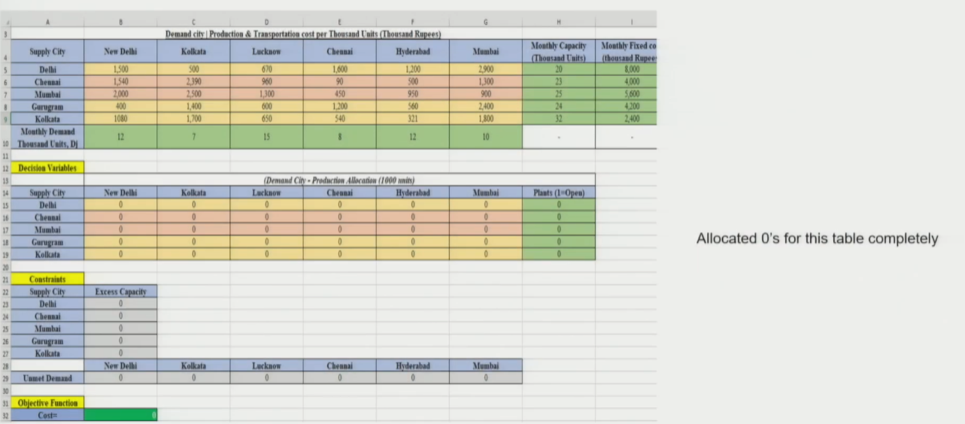
Formulas used:
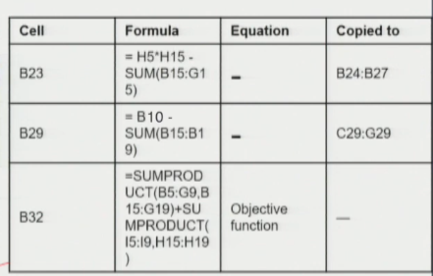
Results:
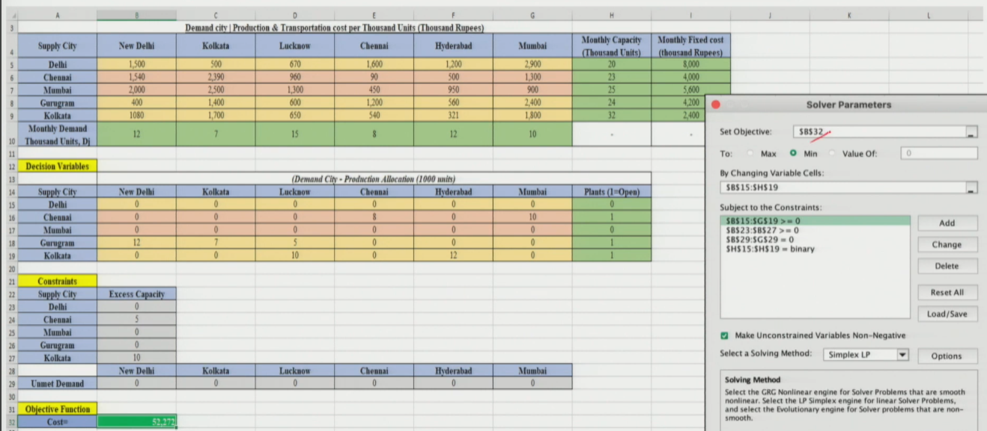
6. Results & Cost Comparison
CPLP Solution (Maxvie — Merged)
- Optimal plants to keep open: Chennai, Gurugram, Kolkata — only 3 out of 5
- Plants closed: Delhi and Mumbai — cost savings from avoiding their fixed costs
- All market demands still fully satisfied

Cost Component | Maxxio (₹) | Waivie Comms (₹) | Maxvie Merged (₹)
Variable (Prod + Trans) | 1,74,50,000 | 1,57,20,000 | —
Fixed Cost | 1,46,00,000 | 96,00,000 | —
Total Monthly Cost | 3,20,50,000 | 2,53,20,000 | 5,22,72,000
Combined (Pre-merger) | — | — | 5,73,70,000 (approx)
Monthly Savings | — | — | ~₹50 lakhs / month

- Monthly saving from merger + network redesign: approximately ₹50 lakhs / month
★ Merger alone doesn't save cost — it's the network REDESIGN that reduces cost by closing inefficient plants.
Session Summary
- Demand Allocation Model: decides Xij (how much from plant i to market j) to minimize variable cost — plants are fixed
- CPLP: decides BOTH Xij (flow) AND yi (open/close plant) — minimizes variable + fixed cost
- Key addition in CPLP: binary variable yi + fixed cost fi term in objective
- Solver method: Demand Allocation → Simplex LP; CPLP → Simplex LP with binary/integer constraint
- Merger result: MaxV operates 3 plants (Chennai, Gurugram, Kolkata) instead of 5 → ~₹50L/month saving

★ Exam Tip: Demand Allocation = LP with only Xij as variables. CPLP = LP with Xij + binary yi. The only change to objective is adding Σ(fi × yi).
★ Exam Tip: Supply constraint in CPLP: Σj Xij ≤ Si × yi — this ensures a closed plant (yi=0) cannot supply anything.
★ Exam Tip: Simplex LP for CPLP; GRG Nonlinear for Centre of Gravity. Know WHY: CoG has non-linear distance formula; CPLP is linear.

